1 Walkthrough 35 Responsiveness

<https://sapui5.hana.ondemand.com/#/topic/a96e18b4cd924196b255eb9623431dbb>



2 Core Changed Codes Compared to Last Version:

2.1 InvoiceList.view.xml 将List替换为Table 对列设置不同屏幕尺寸下的表现方式

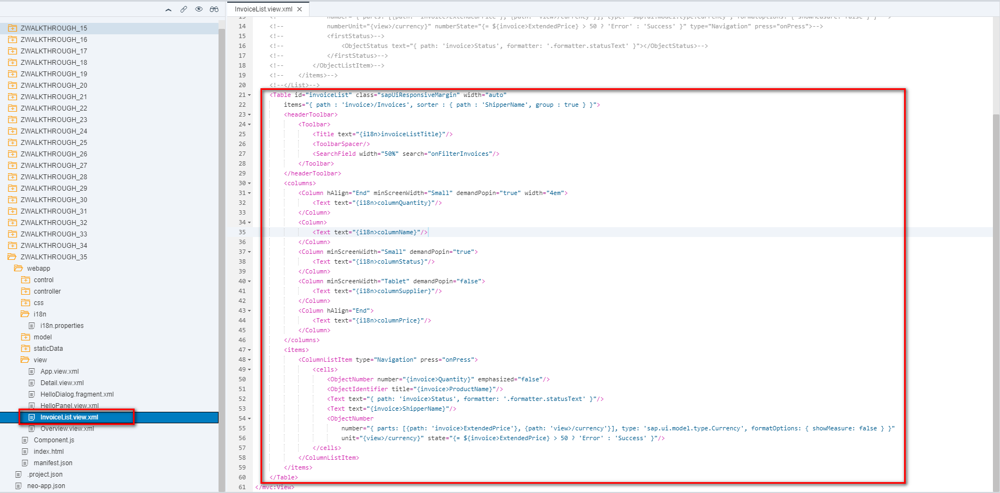

2.2 i18n 列文本对象

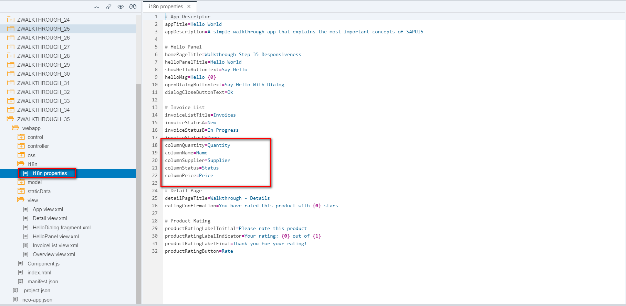

3 Result

PC设备

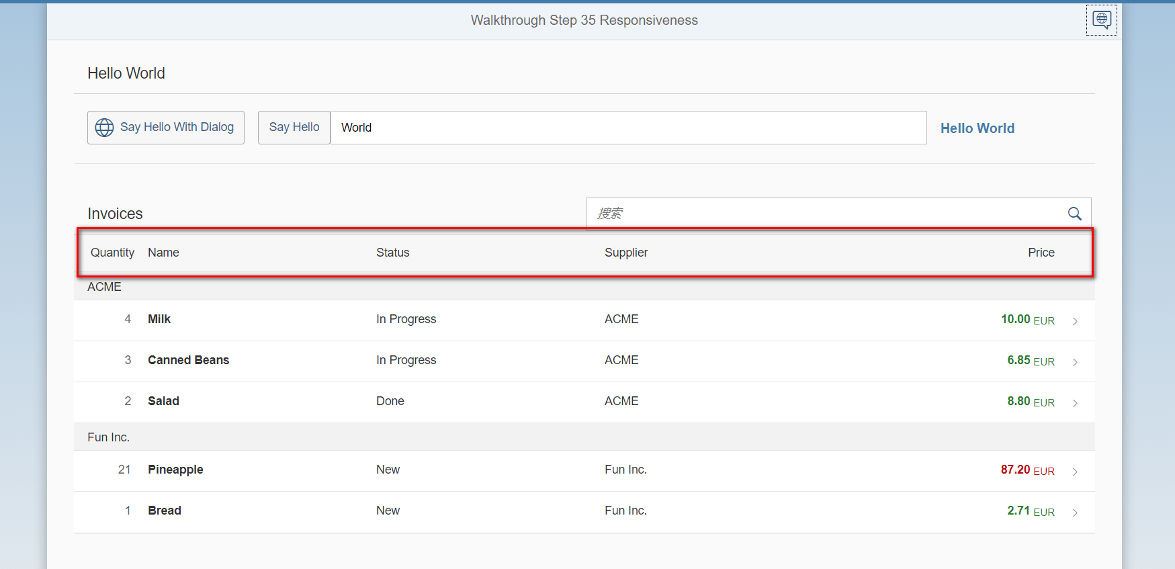

<600 Supplier 列被隐藏

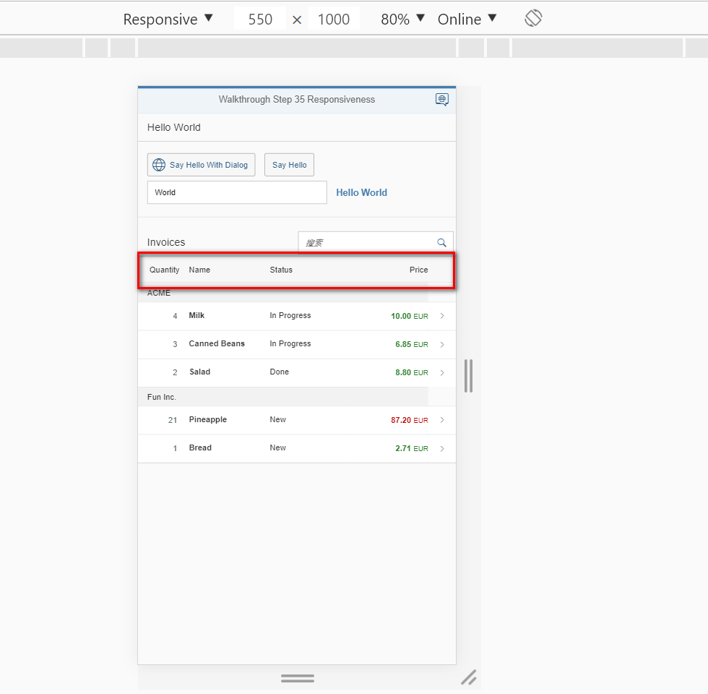

Mobile设备 列数量与状态被移动至列行项目中,以重复表单格式显示

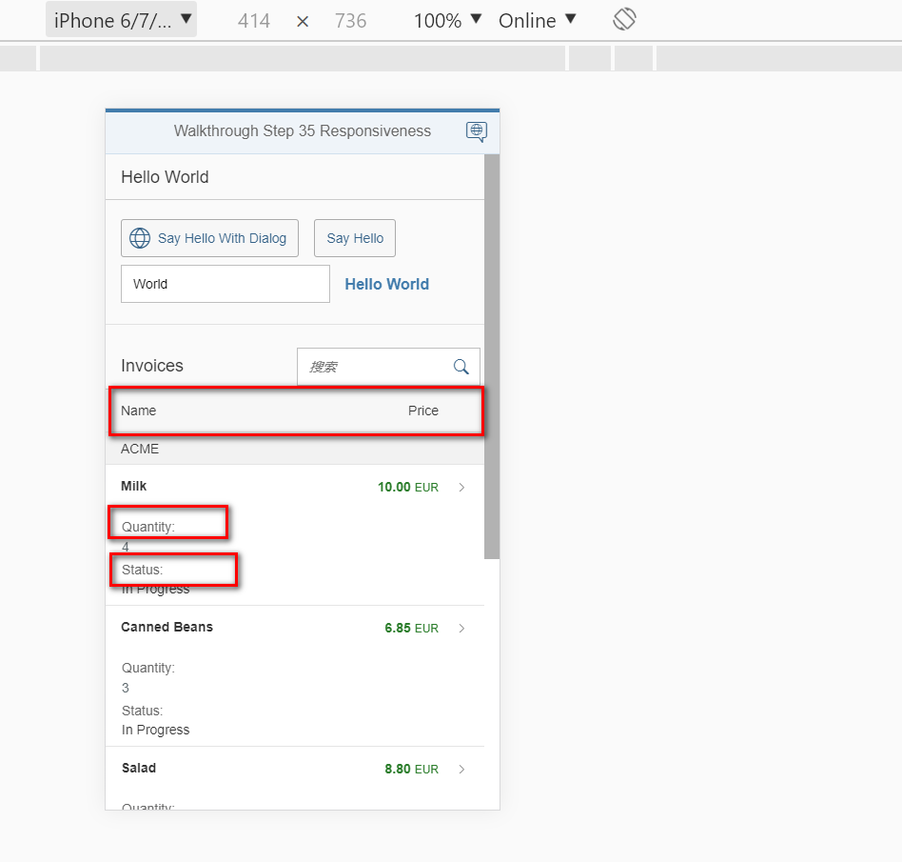

4 Git:

https://github.com/xiexiaop/SAPUI5-2-Round/tree/master/Projects/ZWALKTHROUGH_35

2019/02/08 XiaoMi Beijing Zac,Xie